**Industry report of Commercial Bank**

*As of Q3 2024/25*



Prepared By:

Research Department

Sanima Capital Limited

*sanimacapital@sanimabank.com*

**Introduction**

The Nepali banking sector is showing concerning trends in asset quality, with a clear pattern of rising Non-Performing Loans (NPLs) across most institutions. The sector exhibits significant disparity in NPL management, the sector average has risen dramatically from 3.62% in 2023/24 Q3 to 4.83% in 2024/25 Q3.

The banking industry's P/E and P/B ratios from 2014 to 2024 reflect evolving investor sentiment and valuation perspectives. The P/E ratio saw a sharp rise from 2014 to 2016, peaking at around 30, suggesting strong growth expectations. However, it declined steadily until 2019, indicating a shift to caution as growth prospects dimmed. The slight recovery in 2020-2021 may reflect optimism from economic rebounds and stimulus measures and increase in NEPSE but has since stabilized between 15 and 20, showing moderated growth expectations. In the most recent quarter, the P/E ratio stands at 19.6, showing a slight decrease from the prior quarter, while the P/B ratio remains low at around 1.51. This could imply that while earnings expectations have improved slightly, the market still values banks close to their book value, indicating cautious investor sentiment.

The chart illustrates the trends of the NEPSE index, the Banking index, and the P/E ratio of the banking sector from 2014/15 Q1 to 2024/25 Q2. The NEPSE and Banking indices exhibit similar trends, with the Banking index reflecting slightly less volatility. The fluctuating P/E ratio indicates changing market perceptions of the banking sector’s growth potential and risks. The current banking sector PE of approximately 15-20x represents a middle ground between historical peaks and troughs, suggesting neither extreme overvaluation nor undervaluation on a historical basis.

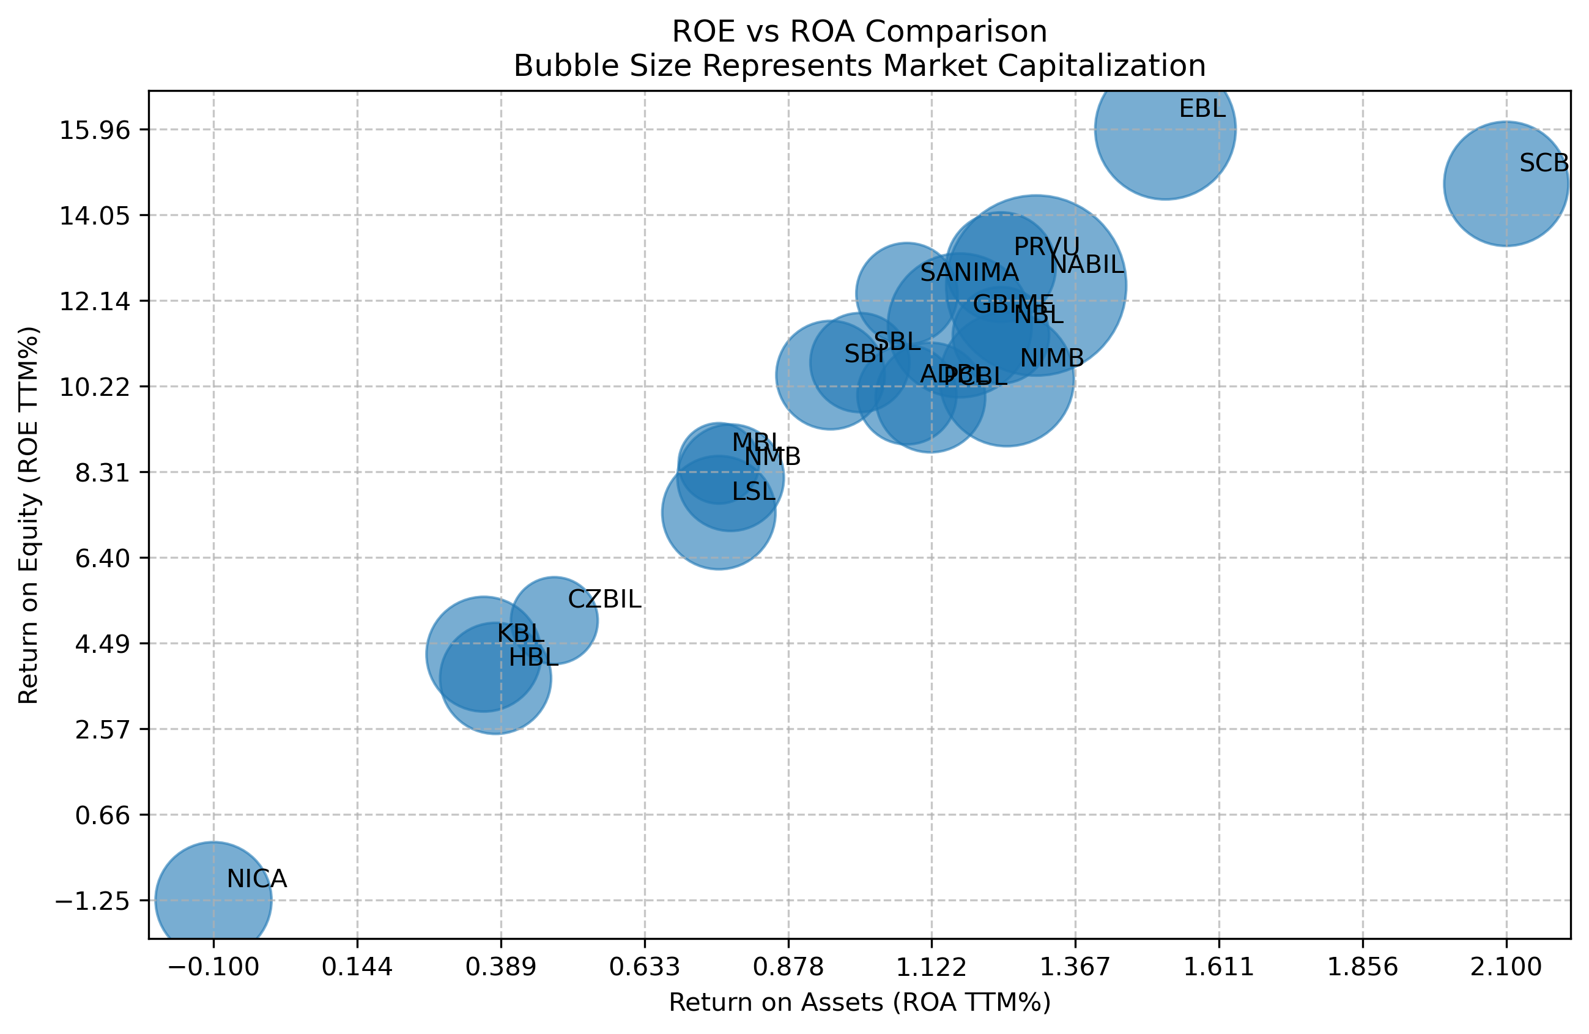

The bubble chart visualizes the relationship between Return on Equity (ROE)(TTM) and Return on Assets (ROA)(TTM) for various commercial banks, with bubble sizes representing market capitalization.   
The chart effectively highlights the varying levels of profitability and asset efficiency among commercial banks. SCB, ADBL, and EBL demonstrate high ROE and ROA values, reflecting strong profitability and efficient operations, making them attractive to investors. Conversely, banks like NICA, KBL HBL with low ROE and ROA may face challenges in improving profitability. This data helps in identifying banks that balance growth with profitability and those that might be undervalued or have potential for improvement.

**Debenture that has matured this year**

|  |  |  |  |  |  |  |
| --- | --- | --- | --- | --- | --- | --- |
| S.n. | Issuer | Ticker | coupon rate | maturity | subscribed amount | Par value |
| 1 | NICA | NICAD8182 | 7.25% | January 8, 2025 | 3,000,000,000 | 1,000 |

NICA has matured 7.25% bond with 3 billion

**Debenture maturing in the next two years**

|  |  |  |  |  |  |  |
| --- | --- | --- | --- | --- | --- | --- |
| S.n. | Issuer | Ticker | coupon rate | maturity | subscribed amount | Par value |
| 1 | NICA | NICAD8283 | 11.00% | September 20, 2025 | 1,830,000,000 | 1,000 |
| 2 | SBL | SBLD2082 | 10.50% | January 13, 2026 | 2,162,559,000 | 1,000 |
| 3 | NIB | NIBD2082 | 10.50% | June 19, 2026 | 2,000,000,000 | 1,000 |

NICA is maturing 11% also maturing in 2025 next fiscal year. SBL and NIB have issued bonds with a coupon rate of 10.50%, maturing in 2026.

As these debentures matured, there are high chances of to increase their dividend capacity as they do not have to transferred their portions of profits to the debenture redemption reserves.

**Dividend Announced till date**

|  |  |  |  |  |  |  |  |
| --- | --- | --- | --- | --- | --- | --- | --- |
| S.N. | Symbol | Company | Bonus (%) | Cash (%) | Total (%) | Announcement Date | Book Closure Date |
| 1 | [ADBL](https://www.sharesansar.com/company/adbl) | [Agricultural Development Bank Limited](https://www.sharesansar.com/company/adbl) | 3.00 | 7.53 | 10.53 | 2024-12-19 | 2024-12-31 [Closed] |
| 2 | [SBL](https://www.sharesansar.com/company/sbl) | [Siddhartha Bank Limited](https://www.sharesansar.com/company/sbl) | 0.00 | 4.00 | 4.00 | 2024-12-08 | 2024-12-29 [Closed] |
| 3 | [SBI](https://www.sharesansar.com/company/sbi) | [Nepal SBI Bank Limited](https://www.sharesansar.com/company/sbi) | 3.8 | 6.85 | 10.65 | 2024-12-04 | 2024-12-22 [Closed] |
| 4 | [LSL](https://www.sharesansar.com/company/lsl) | [Laxmi Sunrise Bank Limited](https://www.sharesansar.com/company/lsl) | 5.00 | 0.26 | 5.26 | 2024-12-01 | 2025-01-01 [Closed] |
| 5 | [SCB](https://www.sharesansar.com/company/scb) | [Standard Chartered Bank Nepal Limited](https://www.sharesansar.com/company/scb) | 6.5 | 19.00 | 25.5 | 2024-11-19 | 2024-11-27 [Closed] |
| 6 | [NABIL](https://www.sharesansar.com/company/nabil) | [Nabil Bank Limited](https://www.sharesansar.com/company/nabil) |  | 10.00 | 10.00 | 2024-10-30 | 2024-11-25 [Closed] |
| 7 | [PCBL](https://www.sharesansar.com/company/pcbl) | [Prime Commercial Bank Limited](https://www.sharesansar.com/company/pcbl) | 0.00 | 5.00 | 5.00 | 2024-10-27 | 2024-11-24 [Closed] |
| 8 | [SANIMA](https://www.sharesansar.com/company/sanima) | [Sanima Bank Limited](https://www.sharesansar.com/company/sanima) |  | 5.2632 | 5.2632 | 2024-10-09 | 2024-11-10 [Closed] |
| 9 | [GBIME](https://www.sharesansar.com/company/gbime) | [Global IME Bank Limited](https://www.sharesansar.com/company/gbime) | 5.5 | 0.00 | 5.5 | 2024-10-08 | 2024-11-24 [Closed] |
| 10 | [CZBIL](https://www.sharesansar.com/company/czbil) | [Citizens Bank International Limited](https://www.sharesansar.com/company/czbil) | 4.00 | 0.21 | 4.21 | 2024-09-23 | 2024-10-15 [Closed] |
| 11 | [EBL](https://www.sharesansar.com/company/ebl) | [Everest Bank Limited](https://www.sharesansar.com/company/ebl) | 10.00 | 5.53 | 15.53 | 2024-09-06 | 2024-09-24 [Closed] |

Out the 19 listed commercial bank 8 banks ADBL, KBL, MBL,NBL,NIMB,NICA,NMB, PRVU have not given any dividend for the fiscal year 2080/81.

**AGM and its Agenda analysis**

|  |  |  |
| --- | --- | --- |
| Symbol | AGM | Agenda |
| NMB | 29th AGM | Financial Highlight of 2080/81, Appointment of Auditor,  Change on Equity, Consolidated Reports of NMB Capital Limited, NMB Laghubitta Bittiya Sanstha Limited and NMB Securities Limited of 2080/81,  Issuance of 8.25% Non-Cumulative Preference Share,  Increment on Authorized and Paid-Up Capital,  Amendment in Articles of Association |
| SBL | 23rd AGM | Financial Highlights of 2080/81, Change in Equity, Consolidated Financial statement of bank's subsidiary company "Siddhartha Capital Ltd" of 2080/81, Appointment of Auditor, Election of Director, 4% Cash Dividend, Issuance of SBL 8.25% Perpetual Non-Cumulative Preference Shares, Increment on Company's Authorized and Issued Capital, Amendment on Memorandum and Articles of association |
| KBL | 24th AGM | Financial Highlight of 2080/81, Financial Highlights of Assisting Company Kumari Capital Limited and K.B.L. Securities Limited for the year 2080/81, Appointment of Auditor |
| MBL | 26th AGM | Financial Highlights of 2080/81, Consolidated Financial Statement of the Assisting Company, Machhapuchchhre Capital Limited and Machhapuchchhre Securities Limited of 2080/81, Appointment of Auditor, Approval on appointed promoter shareholders, Election of Directors, Addendum on Management of Non-cumulative preference share on share structure, Amendment on Memorandum and Articles of association |
| EBL | 30th AGM | Financial Highlights of 2080/81, 10% Bonus Shares, 5.53% Cash Dividend, Appointment of Auditor, Election of Directors, Amendment on Memorandum and Articles of association |
| SBI | 31st AGM | Financial Highlight of 2080/81, Appointment of Auditor, Consolidated Reports of 2080/81 of Nepal SBI Merchant Banking Limited, 6.85% Cash Dividend, 3.80 % Bonus Share, Merger/Acquisition related agendas, Amendment in Articles of Association |
| HBL | 32nd AGM | Financial Highlight of 2080/81, Appointment of Auditor, Consolidated Report of the Assisting Companies Shree Himalayan Capital Limited, Shree Himalayan Securities Limited and Himalayan Laghubitta Bittiya Sanstha Limited of 2080/81, Information on Decisions for the Appointment of Independent Director, Issuance of FPO in Premium Price, Increment on Company's Issued and Paid-up Capital, Amendment on Memorandum and Articles of association |
| SCB | 38th AGM | Financial Highlights of 2080/81, Appointment of Auditor, Change on Equity, 19% Cash Dividend, 6.50% Bonus Share, Increment on Authorized and Issued Capital, Amendment in Articles of Association |
| NABIL | SGM | Proposal Pass to issue "Nabil 8% Abimochhya Asanchitti Agradhikar Share", Increment on Company's Authorized and Issued Capital, Amendment on Memorandum and Articles of association |
| NABIL | 40th AGM | Financial Highlight of 2080/81, Appointment of Auditor, Consolidated Reports of Assisting Companies Nabil Investment Banking Limited and Nabil Stock Dealer Limited for the year 2080/81, 10% Cash Dividend, Election of Directors, Approval on Nominated of Promoter Director from the IFIC Bank PLC, Bangladesh, Merger/Acquis ion related agenda, Amendment on Memorandum |
| CZBIL | 18th AGM | Financial Highlights of 2080/81, Appointment of Auditor, 0.21% Cash Dividend, 4% Bonus Share, Approval on Appointed Directors, Appointment of National/International Recognized Evaluator, Merger/Acquisition related agenda, Increment on Company's Issued and Paid-Up Capital, Type of Bank's Share, Prohibit of purchase/transfer of Shares, Minimum Share Quantity to be a Director, Regarding the right to vote, Rights and special facilities of shareholders, Management of Preference Share, Amendment on Memorandum and Articles of association |
| PCBL | 17th AGM | Financial Highlight of 2080/81, Appointment of Auditor, 5% Cash Dividend, Merger/Acquisition related agenda, Amendment on Memorandum |
| ADBL | 18th AGM | Financial Highlights of 2080/81, Change in Equity, Appointment of Auditor, Consolidated Report of Assisting Company Kosh Bewasthapan Company Limited and Gober Gas Company Limited of 2080/81, 7.53% Cash Dividend, 3% Bonus Shares, Increment on Company's Issued and Paid-up Capital, Amendment on Memorandum and Articles of association |
| SANIMA | 20th AGM | Financial Highlights of 2080/81, Consolidated Report of Sanima Capital Limited and Sanima Securities Limited of 2080/81, Appointment of Auditor, 5.2632% Cash Dividend, Issuance of 8.25% Sanima Perpetual Non-Cumulative Preference Shares, Increment on Company's Authorized and Issued and Paid-Up Capital, Amendment on Memorandum and Articles of association |
| RBBL | 19th AGM | Financial Highlight of 2080/81, Appointment of Auditor, Amendment on Memorandum of association |
| GBIME | 18th AGM | Financial Highlights of 2080/81, Consolidated Reports of Global IME Capital Limited, Global IME Laghubitta Bittiya Sanstha Limited & Global IME Securities Limited (former JBNL Securities Limited) for the FY2080/81, Appointment of Auditor, Information on Appointed Independent Director, 5.50% Bonus Shares, Increment on Authorized and Paid-Up Capital, Amendment in Articles of Association |
| PRVU | 23rd AGM | Financial Highlights of 2080/81, Consolidated Report of Prabhu Capital Limited and Prabhu Stock Market Limited, Appointment of Auditor, Election of Directors |
| LSL | 24th AGM | Financial Highlight of 2080/81, Appointment of Auditor, 0.26% Cash Dividend, 5% Bonus Shares, Approval on Appointment of Directors from Promoter, Increment on company's authorized capital, Amendment in Articles of Association |

**Multiple banks have merger/acquisition related agendas:**

* Nepal SBI Bank
* Nabil Bank
* Citizens Bank International
* Prime Commercial Bank

**Special corporate actions:**

* Himalayan Bank is planning to issue FPO at premium price
* Citizens Bank has included several governance-related items like prohibiting share transfers, minimum shareholding for directors, and voting rights

**Preference Share Issuances:**

* NMB Bank: 8.25% Non-Cumulative Preference Share
* Siddhartha Bank: 8.25% Perpetual Non-Cumulative Preference Share
* Nabil Bank: 8% "Abimochhya Asanchitti Agradhikar Share"
* Sanima Bank: 8.25% Perpetual Non-Cumulative Preference Share

**Summary of the Report with relative valuation**

|  |  |  |  |  |  |  |  |  |
| --- | --- | --- | --- | --- | --- | --- | --- | --- |
| Abb | DDPS (annualized) | DDPS (total) (actual) | ICPS | EPS | BVPS | Price | PE | PV |
| EBL | 22.70 | 28.42 | 2.11 | 35.61 | 235.47 | 625.04 | 17.55 | 2.65 |
| SANIMA | 13.95 | 16.19 | 10.34 | 16.22 | 161.32 | 309.54 | 19.08 | 1.92 |
| SCB | 18.78 | 14.65 | (0.99) | 28.86 | 208.43 | 630.07 | 21.83 | 3.02 |
| ADBL | 14.60 | 13.79 | 6.62 | 17.75 | 225.64 | 290.92 | 16.39 | 1.29 |
| NABIL | 12.29 | 10.62 | 8.48 | 24.89 | 226.36 | 492.09 | 19.77 | 2.17 |
| SBI | 5.81 | 9.65 | 6.66 | 14.72 | 183.08 | 442.68 | 30.07 | 2.42 |
| GBIME | 12.35 | 9.31 | 8.16 | 15.86 | 173.47 | 222.8 | 14.05 | 1.28 |
| PCBL | 11.73 | 8.93 | 12.02 | 15.32 | 164.63 | 254.09 | 16.59 | 1.54 |
| NMB | 10.21 | 7.14 | 7.04 | 17.23 | 171.88 | 253.39 | 14.71 | 1.47 |
| LSL | 4.12 | 3.17 | 13.14 | 9.05 | 176.16 | 216.31 | 23.91 | 1.23 |
| NBL | 11.54 | 2.08 | 1.21 | 25.26 | 260.74 | 259.2 | 10.26 | 0.99 |
| SBL | 1.62 | 1.34 | 15.73 | 15.79 | 207.48 | 286.08 | 18.12 | 1.38 |
| CZBIL | 1.33 | 1.10 | 14.65 | 8.68 | 152.75 | 209.51 | 24.13 | 1.37 |
| MBL | 4.94 | 0.61 | 6.16 | 12.65 | 156.23 | 228.68 | 18.08 | 1.46 |
| NIMB | 17.93 | (3.24) | 3.51 | 17.74 | 190.39 | 216.29 | 12.19 | 1.14 |
| PRVU | (2.13) | (14.44) | 5.26 | 10.63 | 147.29 | 209.57 | 19.72 | 1.42 |
| NICA | (8.06) | (23.93) | 20.45 | 1.40 | 199.30 | 369.81 | 263.91 | 1.86 |
| KBL | (5.76) | (24.79) | 19.70 | 1.45 | 134.43 | 205.96 | 141.73 | 1.53 |
| HBL | 0.48 | (34.00) | 6.09 | 3.08 | 171.44 | 233.62 | 75.88 | 1.36 |

The table includes key financial metrics for each bank, such as impairment charge per share, Distributable Dividend per share (DDPS) as of Q3 and retained earnings, EPS as of Q3, book value per share (BVPS), Price, P/E ratio, and P/B ratio.

**Impairment and Dividend Analysis:**

EBL, SCB, and NABIL emerge as the strongest performers with robust dividend yields (DDPS), healthy earnings per share (EPS), and reasonable valuation metrics. EBL stands out with the highest annualized DDPS (22.70) and strong EPS (35.61), justifying its premium pricing and solid price-to-book value (PV 2.65). SCB commands the highest share price (630.07) with strong fundamentals, though its negative ICPS (-0.99) suggests excellent asset quality requiring minimal impairment charges.

**Dividend Performance**

* **Top Performers**: EBL leads with exceptional actual DDPS of 28.42, followed by SANIMA (16.19) and SCB (14.65)
* **Solid Mid-Range**: ADBL (13.79), NABIL (10.62), SBI (9.65), and GBIME (9.31) provide reliable dividend returns
* **Concerning Trends**: Five banks show negative actual DDPS, with HBL (-34.00), KBL (-24.79), and NICA (-23.93) exhibiting severe distribution issues
* **Dividend Inconsistency**: Notable discrepancy between annualized and actual DDPS for some banks (e.g., NIMB: 17.93 vs -3.24) suggests potential dividend sustainability concerns

**Valuation Analysis**

* **PE Ratio Concerns**: NICA (263.91) and KBL (141.73) show extreme overvaluation relative to earnings
* **Value Opportunities**: NBL (10.26), NIMB (12.19), GBIME (14.05), and NMB (14.71) present attractive PE ratios
* **Price-to-Book Value**: SCB (3.02) and EBL (2.65) trade at premium valuations, while NBL (0.99) trades below book value

**Risk Assessment**

* High impairment charges (ICPS) at several banks suggest potential asset quality deterioration in parts of the sector
* Negative dividend distributions at multiple institutions warrant careful monitoring of capital adequacy and regulatory compliance

**Impairment charge MRQ**

|  |  |  |  |  |  |  |  |
| --- | --- | --- | --- | --- | --- | --- | --- |
| MRQ Data | 2024/25 | 2024/25 | 2024/25 | 2023/24 | 2023/24 | 2023/24 | 2023/24 |
|  | Q3 | Q2 | Q1 | Q4 | Q3 | Q2 | Q1 |
| KBL | 1,894,031 | 2,642,453 | 630,689 | 20,593 | 777,608 | 582,937 | 2,183,140 |
| PCBL | 1,470,059 | 451,074 | 410,456 | 348,826 | 613,912 | 64,463 | 216,649 |
| LSL | 1,269,270 | 761,264 | 1,167,991 | (582,605) | 1,269,042 | 586,088 | 2,146,521 |
| HBL | 1,134,917 | 507,103 | (322,502) | 529,444 | 309,438 | 1,191,315 | 756,622 |
| NMB | 948,330 | 381,804 | (37,039) | 1,117,615 | (154,139) | 477,432 | 480,169 |
| NABIL | 942,199 | 893,282 | 457,727 | (11,553) | 1,264,152 | 860,124 | 1,111,667 |
| GBIME | 906,385 | 1,131,972 | 1,071,776 | (1,521,324) | 1,128,607 | 2,354,246 | 1,781,772 |
| CZBIL | 778,729 | 476,220 | 909,135 | 779,511 | 126,210 | 433,027 | 426,474 |
| NICA | 690,595 | 1,195,336 | 1,164,337 | 695,795 | 1,668,493 | (164,269) | 644,307 |
| SANIMA | 642,367 | 198,786 | 563,166 | (103,103) | 752,404 | 302,370 | 542,701 |
| MBL | 510,982 | 248,119 | (43,416) | 127,885 | 705,726 | 226,299 | 12,290 |
| SBI | 486,604 | 516,844 | (277,616) | (163,645) | 51,619 | 451,565 | 296,856 |
| PRVU | 423,788 | 430,054 | 384,170 | (1,201,834) | 500,878 | 1,178,349 | 79,418 |
| SCB | 151,760 | (193,583) | (57,198) | (33,933) | 198,651 | 31,131 | 20,265 |
| ADBL | 59,317 | (44,757) | 902,261 | (288,748) | 425,853 | (1,063,571) | 2,160,076 |
| SBL | (48,691) | 1,260,132 | 1,005,014 | (478,233) | 525,857 | (249,499) | 1,433,563 |
| EBL | (76,650) | 242,894 | 106,704 | (354,782) | 204,841 | 2,843 | 429,502 |
| NIMB | (574,427) | 797,430 | 975,163 | 155,861 | 181,929 | 2,227,171 | 640,675 |
| NBL | (2,244,624) | 1,838,950 | 688,492 | (1,063,401) | 1,582,816 | 735,475 | 1,341,793 |

**Analysis of NRB required Key indicators**

|  |  |  |  |  |  |  |  |  |  |
| --- | --- | --- | --- | --- | --- | --- | --- | --- | --- |
| Abb | Tire 1 RWA Q3 | Capital Fund to RWA | Non-Performing Loan (NPL) to Total Loan | Total Loan Loss Provision to Total NPL | Credit Deposit Ratio as per NRB Calculations | Cost of Funds | Net Interest Spread | Base Rate | Base Rate - Cost of Fund |
| PCBL | 10.02% | 11.39% | 5.65% | 100.74% | 84.80% | 5.47% | 3.65% | 6.82% | 1.35% |
| MBL | 8.80% | 12.68% | 4.59% | 91.27% | 84.76% | 4.42% | 3.87% | 6.52% | 2.10% |
| CZBIL | 8.98% | 12.34% | 5.71% | 87.45% | 84.21% | 4.77% | 4.00% | 8.99% | 4.22% |
| EBL | 9.81% | 12.67% | 0.64% | 258.93% | 84.07% | 4.11% | 3.67% | 5.61% | 1.50% |
| NMB | 9.27% | 12.18% | 4.47% | 89.35% | 83.97% | 5.24% | 3.80% | 6.49% | 1.25% |
| SBL | 9.20% | 11.18% | 4.04% | 92.75% | 83.96% | 4.62% | 3.98% | 6.43% | 1.81% |
| NICA | 9.13% | 13.42% | 5.75% | 89.22% | 83.47% | 5.12% | 4.00% | 7.20% | 2.08% |
| LSL | 9.28% | 11.76% | 5.86% | 92.28% | 82.48% | 4.71% | 3.67% | 6.72% | 2.01% |
| NABIL | 9.45% | 11.72% | 4.96% | 96.57% | 82.31% | 4.59% | 3.57% | 5.97% | 1.38% |
| SANIMA | 9.54% | 12.93% | 3.42% | 101.31% | 81.04% | 4.99% | 3.60% | 6.43% | 1.44% |
| KBL | 7.31% | 11.82% | 6.98% | 136.62% | 79.84% | 5.05% | 3.52% | 6.78% | 1.73% |
| HBL | 8.00% | 10.84% | 7.68% | 101.17% | 79.38% | 5.03% | 3.55% | 6.80% | 1.77% |
| GBIME | 10.09% | 12.36% | 4.98% | 95.34% | 78.04% | 4.65% | 3.79% | 6.38% | 1.73% |
| NIMB | 10.51% | 13.33% | 6.06% | 102.64% | 76.76% | 4.39% | 3.45% | 6.10% | 1.71% |
| ADBL | 9.64% | 13.12% | 4.98% | 96.52% | 76.33% | 4.15% | 3.93% | 6.09% | 1.94% |
| SBI | 9.47% | 12.44% | 4.06% | 91.37% | 75.49% | 5.35% | 3.77% | 6.73% | 1.38% |
| PRVU | 8.67% | 12.84% | 5.09% | 158.57% | 73.33% | 4.62% | 3.90% | 6.73% | 2.11% |
| SCB | 15.15% | 17.44% | 1.44% | 177.89% | 72.94% | 3.30% | 4.00% | 5.09% | 1.79% |
| NBL | 10.09% | 12.97% | 5.45% | 90.18% | 72.71% | 3.96% | 3.86% | 5.96% | 2.00% |

This table provides insights into several key financial metrics for banks, including capital fund to RWA (Risk-Weighted Assets), non-performing loans (NPL) to total loan ratios, loan loss provisions, credit-deposit ratios, cost of funds, net interest spread, and base rates.

**Capital Adequacy**

* **Superior Capital Buffer**: SCB leads with exceptional capital fund to RWA ratio of 17.44%, far exceeding regulatory minimum
* **At-Risk Position.** The minimum Tier 1 requirement of 8.5%, HBL operates with the thinnest capital buffer at 8.00% Tier 1 and 10.84% Capital Fund, placing it in a potentially vulnerable position should asset quality deteriorate further. KBL shows concerning Tier 1 levels at 7.31%, falling below the regulatory minimum. The bank will have restriction of loan growth and dividend distribution.
* **Well-Capitalized Tier**: NIMB (10.51% Tier 1, 13.33% Capital Fund), NICA (9.13% Tier 1, 13.42% Capital Fund), and ADBL (9.64% Tier 1, 13.12% Capital Fund).

**Asset Quality**

* **Best Performers**: EBL demonstrates superior asset quality with remarkably low NPL ratio (0.64%)
* **Concerning NPLs**: HBL (7.68%) and KBL (6.98%) show significantly elevated non-performing loans, indicating potential credit quality issues
* **Loss Provision Strength**: EBL maintains exceptional coverage with 258.93% provision to NPL ratio, followed by SCB (177.89%)
* **Underprovided Risk**: NBL (90.18%), NICA (89.22%), and CZBIL (87.45%) show the weakest provision coverage

**Liquidity Position**

* **Higher CD ratio**: PCBL (84.80%), MBL (84.76%), and EBL (84.07%) are efficiently utilizing the fund.
* **Liquidity Comfort**: NBL (72.71%) and SCB (72.94%) maintain the most conservative lending relative to deposits

**Profitability Metrics**

* **Funding Cost Pressure**: PCBL (5.47%), SBI (5.35%), and NMB (5.24%) face the highest cost of funds
* **Funding Advantage**: SCB (3.30%) enjoys the lowest cost of funds, enhancing profitability potential
* **Interest Spread Leaders**: NICA, SCB, and CZBIL all maintain strong 4.00% net interest spreads Max allowed by the NRB.

**Competitive Positioning**

* **Efficiency Leaders**: SCB combines low funding costs (3.30%) with strong spread (4.00%), creating excellent interest margins
* **Pressure Points**: Banks with high NPLs (HBL, KBL) and high funding costs (PCBL, SBI) face profitability challenges

**Risk-Reward Analysis**

* EBL presents an optimal balance of low NPLs, strong provisions, reasonable funding costs, and adequate spreads
* HBL's combination of high NPLs, low capital, and high funding costs creates a concerning risk profile
* CZBIL's extraordinarily high base rate (8.99%) suggests either premium pricing power or potentially risky lending practices

**Net Profit Comparison**

The chart presents a year-over-year (YOY) comparison of net profits for Q3 of the fiscal years 2023/24 and 2024/25 for various banks.

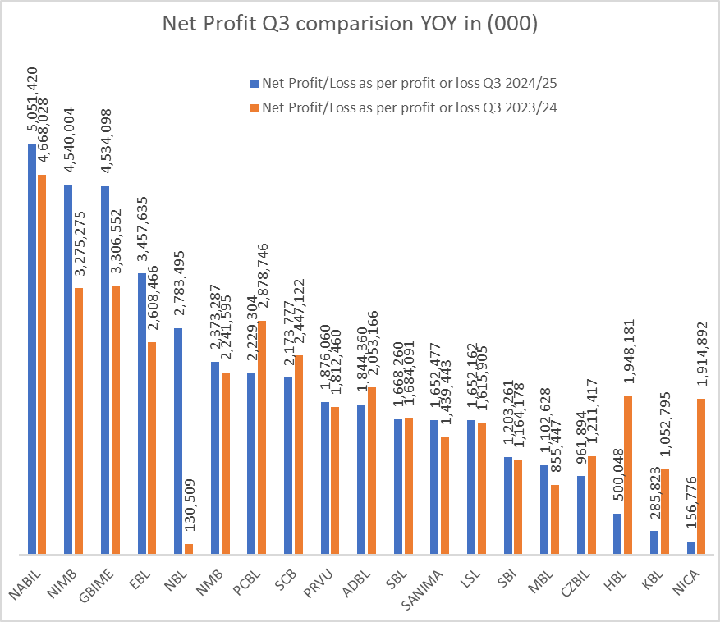

* **NBL** exhibits the most improvement, moving from a negligible 130,509 to a substantial 2,783,495 ('000s), suggesting significant operational enhancements
* **NMB** shows healthy growth from 2,247,359 to 2,711,904 ('000)
* **NICA**, **KBL**, and **HBL** display the weakest performance, with NICA experiencing a severe drop from 1,914,892 to just 156,776 ('000s)
* **HBL**'s decline from 1,948,181 to 500,048 and **KBL**'s drop from 1,052,795 to 285,823 align with their concerning metrics in previous analyses. YOY profit declines, due to higher impairment charges or rising non-performing loans (NPLs).

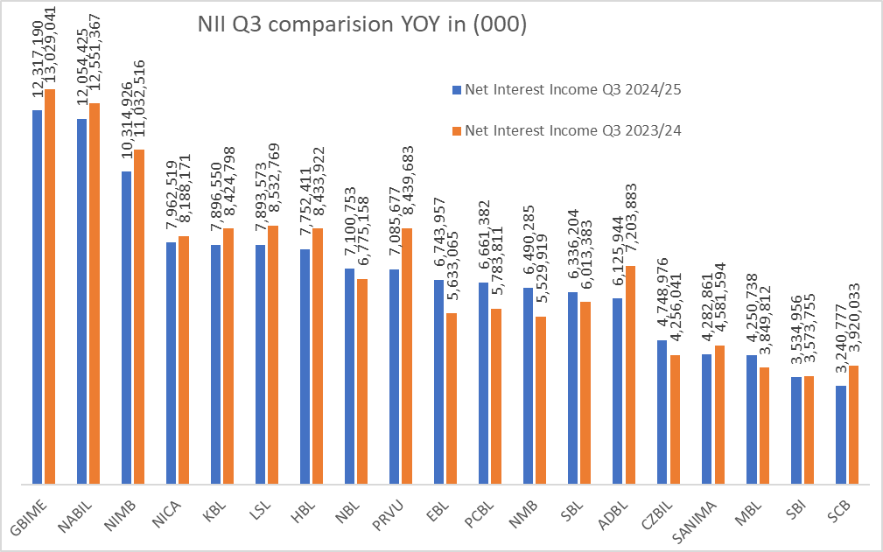

The chart compares the Net Interest Income (NII) for Q3 of the fiscal years 2023/24 and 2024/25 for various banks. This comparison indicates the varying performance of banks in leveraging their interest-earning assets, with some achieving notable growth while others face stagnation or limited increases in NII.

* Out of 19 listed commercial banks only 7 have increased in NII and rest have decreased the NII.

**Analysis of Loans. Deposit Growth in Nepalese Banking Sector**

The chart compares the increase in loan and deposit amounts (in billions) for various banks between Q2 of 2023/24 and Q3 of 2024/25. It also shows the percentage growth for both loans and deposits over the year.

**Market Leaders**

* GBIME maintains the largest loan portfolio (427.9 billion) with strong 12.4% growth
* NABIL dominates deposit collection with 502.1 billion, growing at 14.0%
* Both institutions demonstrate balanced, sustainable expansion across both sides of the balance sheet

**Growth leaders.**

* EBL shows exceptional growth metrics: 20.8% in loans and 24.2% in deposits
* NBL demonstrates robust expansion with 16.0% loan growth and 20.0% deposit growth
* NMB achieves strong balanced growth (17.4% loans, 20.0% deposits)

**Growth decrease**

* PRVU (-2.9%) and KBL (-2.4%) show deliberate loan contraction while growing deposits,
* NICA exhibits significant contraction in both loans (-15.3%) and deposits (-10.1%). Mostly due to the tight CAR
* HBL shows near-stagnant growth (0.2% loans, 0.8% deposits). HBL also has tight CAR
* Both NICA and HBL institutions confirm fundamental operational challenges identified in earlier metrics

**Overall Trends**

* Deposit growth generally outpaces loan growth across most institutions
* This pattern indicates improving system-wide liquidity
* May create net interest margin pressure in coming quarters but provides foundation for future expansion

This analysis underscores a mixed performance in the banking sector, with certain banks capitalizing on growth opportunities, while others face challenges in expanding their core lending and deposit base. These trends highlight the importance of effective liquidity and credit management to sustain profitability in a competitive environment.

**Conclusion**

The analysis of Nepalese commercial banks for Q3 2024/25 reveals a sector undergoing a period of significant contrasts and challenges. While some banks demonstrate strong growth in core areas like Net Interest Income (NII), loans, and deposits, others are grappling with rising Non-Performing Loans (NPLs), reduced profitability, and operational inefficiencies.

For growth-oriented investors, NABIL, GBIME, and EBL provide the strongest momentum. Income-focused portfolios would benefit from the substantial dividend yields of EBL, SANIMA, and SCB. In contrast, NICA, HBL, and KBL demonstrate persistent weaknesses across multiple dimensions, including significant profit declines, negative dividend distributions, high NPLs, and balance sheet contraction, signaling fundamental operational challenges. The significant deposit growth outpacing loan expansion across much of the sector suggests improved liquidity.

**Disclaimer:**

* *This report is based on publicly available published data and is intended for informational purposes only. Any decision made based on this report are solely at the viewer discretion.*